
Faculty of Data Sciences
Ghulam Ishaq Khan Institute of Engineering Sciences and Technology, Topi

CS311L
Operating System Lab
Fall 2024

Lab No : 1
Lab Title : Introduction

Student Name : Muhammad Bilal
Registration No : 2022360

Submission Date : 1st October 2025
Submitted To : Ms. Mah Rukh

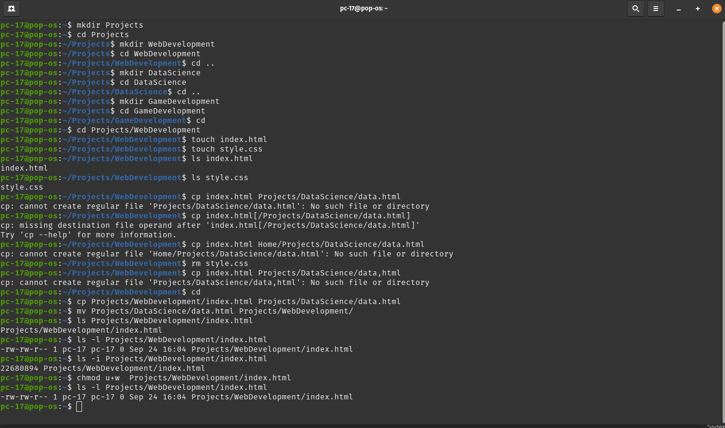
Task 1:
We created a folder named Projects, which contains three subdirectories: Web Development, Data Science, and Game Development. Inside the Web Development directory, two files, `index.html` and `style.css`, were created. We listed their attributes and checked their inode numbers.

Task 2:
We copied `index.html` to the Data Science directory and renamed it to `data.html`. Then, we removed `style.css` from the Web Development directory and moved `data.html` back to Web Development.

Task 3:
We checked the inode number of `index.html`, listed its detailed attributes, and changed its permissions to make it executable by the owner.

